Book

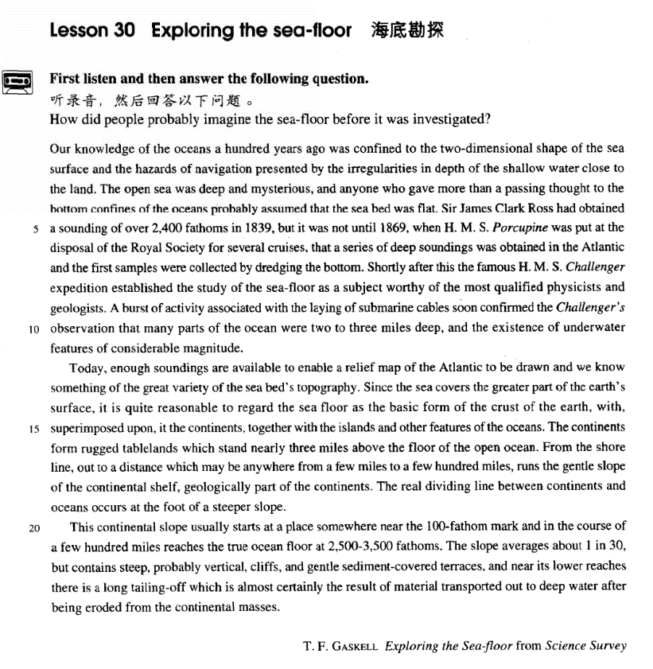

课文

Our knowledge of the oceans 100 years ago was confined to the two-dimensional shape of the sea surface and the hazards of navigation presented by the irregularities in depth of the shallow water close to the land. The open sea was deep and mysterious, and anyone who gave more than a passing thought to the bottom confines of the oceans probably assumed that the sea-bed was flat. Sir James Clark Ross had obtained a sounding of over 2,400 fathoms in 1839,

100年前，我们只知道海洋是二维平面形的，以及靠近陆地浅水区的深浅不一能给航行带来危险。无边无际的海洋深邃而又神秘，凡是稍稍想过大海海底的人大概都会认为海底是平坦的。

but it was not until 1869, when H. M. S. Porcupine was put at the disposal of the Royal Society for several cruises that a series of deep soundings was obtained in the Atlantic and the first samples were collected by dredging the bottom. Shortly after this the famous H. M. S. Challenger expedition established the study of the sea-floor as a subject worthy of the most qualified physicists and geologists.

1839年，詹姆斯.克拉克.罗斯爵士曾测得海水深度超过2，400英寻；但直到1869年，皇家学会用英国“豪猪”号舰艇进行了几次巡航后，才在大西洋测得一个海水深度，同时能过挖掘海底，取得了研究海底的首批样品。此后不久，英国著名的“挑战者”号舰艇对海底的那次考察，把对海床的研究确立为一个值得一流物理学家和地质学家从事的研究课题，

A burst of activity associated with the laying of submarine cables soon confirmed the Challenger's observation that many parts of the ocean were two to three miles deep,

铺设海底电缆的热潮很快证实了“挑战者”号的观察结果：海洋中很多地方可深达两三英里，

and the existence of underwater features of considerable magnitude.

水下特征差异极大。

Today, enough soundings are available to enable a relief map of the Atlantic to be drawn and we know something of the great variety of the sea bed's topography.

现在已有足够的水深测量数据来绘制一张大西洋洋底地形图，而且我对海底地形的千变万化也有了一定的了解。

Since the sea covers the greater part of the earth's surface,

既然海洋覆盖着地球的大部分表面，

it is quite reasonable to regard the sea floor as the basic form of the crust of the earth, with superimposed upon it the continents, together with the islands and other features of the oceans.

因此完全有理由把海床看作地壳的基本模壳，上面附加着大陆以及岛屿和海洋的其他形态。

The continents form rugged tablelands which stand nearly three miles above the floor of the open ocean.

大陆是崎岖不平的高地，高出辽阔的海洋海底近三英里。

From the shore line, out to a distance which may be anywhere from a few miles to a few hundred miles, runs the gentle slope of the continental shelf, geologically part of the continents.

从海岸线向大海延伸几英里到几百英里的区域是大陆架慢坡，从地质学上来说，它是大陆的一部分。

The real dividing line between continents and oceans occurs at the foot of a steeper slope.

大陆和海洋的真正分界线是在陡破脚下。

This continental slope usually starts at a place somewhere near the 100-fathom mark and in the course of a few hundred miles reaches the true ocean floor at 2,500-3,500 fathoms.

大陆架慢坡一般是从差不多100英寻水深的地方开始的，一直延伸到几百英里远深达2，500至3，500的地方，那里才是真正的海底。

The slope averages about 1 in 30, but contains steep, probably vertical, cliffs, and gentle sediment-covered terraces,

坡度平均约为1/30，但其中包括陡峭的、乃至垂直的峭壁和沉积物覆盖的缓和的阶梯地带，

and near its lower reaches there is a long tailing-off which is almost certainly the result of material transported out to deep water after being eroded from the continental masses.

在这个地带的低处是很长的一段尾沙地段，基本上可以断定这个地段是大陆块体上侵蚀下来的物质被水冲到深水处形成的。

词汇讲解

Lesson 30 Exploring the sea-floor

navigation [7nævɪ'geɪʃn]

n. 航海

The channel now is open to navigation. aviation

an electronic navigation system

navigate navigate by the stars You drive and I’ navi ate.

nav / nau = ship

navy naval nausea nauseate nautical nautical chart / mile

aeronautics astronautics

Beijing University ofAeronautics and Astronautics

expedition [7ekspə'dɪʃn]

n. 远征，考察，探险

They went on an expedition to the South Pole. trip a trip around the world

on a fishing trip

journey on a journey

travel

We met some very interesting people on our travels in Thailand. tour

President Xi Jinping is on a five-nation tour. outing go on an outing

excursion

We’re oin on a da excursion to the Bada in Great Wa . cruise / voyage

on a cruise / voyage

pilgrimage

He makes / goes on a pilgrimage to Mecca every year. magnitude

['mægnɪtju:d]

n. 巨大，重大，重要性

magnitude n. great size or importance of something We didn't realize the magnitude of the problem.

a harvest of magnitude

This is a world crisis of considerable magnitude.

ma n reat

magnify magnate

a financial / literary magnate magnanimous magnanimity magnificent magniloquent topography [tə'pɒgrəfi]

n. 地形，地形学

raph write

photograph telegraph

autograph geography

topography biography

autobiography demography bibliography calligraphy crust [krʌst]

n. 地壳

crust

the earth, read, pie, pizza, cake … shell

e , nut, tortoise … tableland ['teɪbllænd]

n. 高地

tableland n. a flat, elevated region 高地

plateau

the Qinghai-Tibet Plateau plain

the North China Plain

basin the Tarim Basin

savannah prairie grassland the Inner Mongolian Grassland

terrace

sediment ['sedɪmənt]

n. 沉淀物

a thick layer of sediment

sed sit

sedate a sedate village sedative sedentary a sedentary occupation sedulous a sedulous researcher erode [ɪ'rəʊd]

v. 侵蚀，腐蚀

Wind and rain have eroded the statue.

Rising domestic prices wi erode China’s competitiveness. eat / wear away

The stones are being eaten / worn away by the river. corrode

Acid corrodes metal.

Our knowledge of the oceans *a hundred years ago* was confined to the two-dimensional shape of the sea surface and the hazards of navigation *presented by the irregularities in depth of the shallow water (close to the*

*land)*.

confine … to …

This attitude seems to be confined to the upper classes. restrict … to …

Our knowledge of the oceans a hundred years ago was restricted to the two-dimensiona shape of the sea surface …

e confined to …

After the operation, she was confined to bed for a week.

Although confined to a wheelchair, she was very active in social life. be a health / safety / fire / traffic hazard

be / present / pose / constitute a hazard to ……

The busy traffic entrance is / presents / poses / constitutes a hazard to pedestrians.

hazardous peril perilous

The ship was in grave peril. (in) jeopardy

A miner’s ife is often in jeopard .

The industria depression put man men’s jo s in jeopard .

be / present / pose / constitute a threat / menace to …

Inf ation ma pose a potentia threat to China’s socia sta i it .

Religious extremism constitutes a grave menace to the security and stability in the region.

The open sea was deep and mysterious, and anyone who gave more than a passing thought to the bottom confines of the oceans probably assumed *that the sea bed was flat*.

give thought / consideration to sth. passing adj. brief and not serious

a passing thought / glance / craze

It is impossible to make more than the wildest guess at how many they ki , …

confines n. limits 范围

It did not, however, remain within the confines of his estate. Some debaters weaken their case by assuming too much. postulate

Ptolemy postulated that the Earth was at the center of the universe. presume

From the way they talked, I presumed that they were a couple. suppose

Sir James Clark Ross had obtained a sounding of over 2,400 fathoms in

1839, but *it was* not until 1869, when H.M.S. Porcupine was put at the disposal of the Royal Society for several cruises, *that* a series of deep soundings was obtained in the Atlantic and the first samples were collected by dredging the bottom.

H.M.S. (HMS)

Her / His Majest ’s Ship

at one’s disposa / at the disposal of sb. 归某人使用

He put / placed his house at my disposal during my holiday.

It was not unti …, when …, that …

造句：直到 1949 年毛主席宣布 (proclaim) 中华人民共和国成立, 中国人民才最终获得了解放 (achieve liberation) 并且成了国家的主人(master)。

It was not until 1949, when Chairman Mao proclaimed the foundation of the People's Republic of China, that the Chinese people finally achieved liberation and became masters of the country.

Only then did he realize he was wrong.

It was only in 1869, when H.M.S. Porcupine was put at the disposal of the Royal Society for several cruises, that a series of deep soundings was …

It was only when H.M.S. Porcupine was put at the disposal of the Royal Societ for severa cruises in 1869, that a series of deep soundin s was …

*Shortly after this* the famous H. M. S. Challenger expedition established

the study of the sea-floor as a subject worthy of the most qualified physicists and geologists.

short after … short efore … shortly afterwards esta ish … as …

He had established himself as a musician by the 1980s.

Zhen He’s seven expeditions esta ished China as the wor d’s top naval power.

e worth of …

be worthy to do / to be done

be worth n. / doing

The day when Beijing won the right to host 2008 Olympic Games is worth being celebrated. X

The day when Beijing won the right to host 2008 Olympic Games is worth celebration / celebrating. √

The day when Beijing won the right to host 2008 Olympic Games is worthy of celebration / to be celebrated. √

qualified

a qualified doctor / architect

qualify

I qualified as a doctor from Peking University last year.

She doesn't qualify for maternity leave because she hasn't been in her job long enough.

authorize sb. to do

UN does not authorize US to use force against Iraq. authorization

US waged war on Iraq without UN authorization.

A burst of activity associated with the laying of submarine cables soon confirmed the challenger's observation that many parts of the ocean were two to there miles deep, and the existence *of underwater features of*

*considerable magnitude*. One more ite, and I’ urst. The buds are all bursting.

burst into tears / laughter / song

burst out crying / laughing / singing

a burst of sth.

a burst of speed / laughter / anger / activity

He showed that the average individual's sleep cycle is punctuated with peculiar bursts of eye-movements, some drifting and slow, others jerky and rapid.

Today, enough soundings are available to enable a relief map of the Atlantic to be drawn and we know something of the great variety *of the sea bed's topography*.

be available to do

Funds are available to assist teachers who want to attend the conference. My professor is always available to talk to her students.

know … about / of …

I don't know anything about this.

Not much is known about his background. You know nothing of this business.

Since the sea covers the greater part of the earth's surface, it is quite reasonable to regard the sea floor as the basic form of the crust of the

earth, *with, superimposed upon it, the continents, together with the islands and other features of the oceans*.

it is (quite) reasonable / legitimate / justifiable for … to do

It is quite reasonable for China to demand Japan to thoroughly rethink the Yasukuni Shrine issue.

It’s a ver we for … to do

It’s a ver we for such thin s to occur in fiction.

… with, superimposed upon it, the continents, together with the islands and other features of the oceans.

… with the continents, to ether with the is ands and other features of the oceans superimposed upon it.

superimpose A on / upon B (with) + n.+ 非谓语

It is possible that upon such an occasion a battle ensued, with the sharks

being driven away or killed.

The continents form rugged tablelands which stand nearly three miles above the floor of the open ocean.

The tower stands 20 meters. measure

The bed measures 2 meters in length / long. The tower stands 20 meters.

measure

The bed measures 1 meter in width / wide. weigh

The boy weighs 50 kilos.

From the shore line, out to a distance which may be anywhere from a few

miles to a few hundred miles, runs the gentle slope of the continental shelf, *geologically part of the continents*.

There was a path running through the middle of the forest.

表示位置或次序的状语置于句首，只要满足两个条件，要用全部倒装。

1、主语不是代词。

2、谓语动词不是及物动词。On the hill stands a temple.

= A temple stands on the hill. In came Miss Green.

= Miss Green came in. Out he went. √

Out went he. X

On the hi John saw Mar . √ On the hill saw John Mary. X Now comes your turn.

Next came a horse. geology geography geometry

The real dividing line between continents and oceans occurs *at the foot a*

*steeper slope*.

Minera s occur in the earth’s crust. exist / be found

Vitamin C is found in citrus fruit.

Pumas are large, cat-like animals which are found in America. be

Such terrible suffering should never be. obtain

Conditions of extreme poverty now obtain in many parts of the country. lie in sth.

The difficulty lies in providing sufficient evidence.

My main interest lies in the development of new technology. lurk

I saw someone lurking in the bushes.

This continental slope usually starts at a place somewhere near the 100-fatheom mark and *in the course of a few hundred miles* reaches the true ocean floor at 2,500-3,500 fathoms.

The slope averages about 1 in 30, but contains steep, probably vertical, cliffs, and gentle sediment-covered terraces, and *near its lower reaches* there is a long tailing-off which is almost certainly the result of material *transported out to deep water after being eroded from the continental*

*masses*. average

The airport averages about a thousand flights a month. 1 in 30: a / one thirtieth

vertical / perpendicular

horizontal circuitous / tortuous

The road is tortuous, but the prospects are bright.

名词+分词 构成形容词

insect-eating animals time-consuming advice hand-made silverware state-owned enterprises flower-selling girls

law-abiding citizens man-eating societies

epoch-making masterpieces town-bred children

the outer reaches of the forest the upper reaches of the river the lower reaches of the river

the upper reaches of the government